Changing a Members details.

Anything you may wish to change is done by a process very similar to adding a new Member
Start the process by logging on.
Please note: you will see none of the information if you haven’t logged in correctly. If you have logged in correctly your name will now be in the black bar towards the top lefthand of the screen.
Step 1.
You will now be on a page called or referred to as the Members overview. 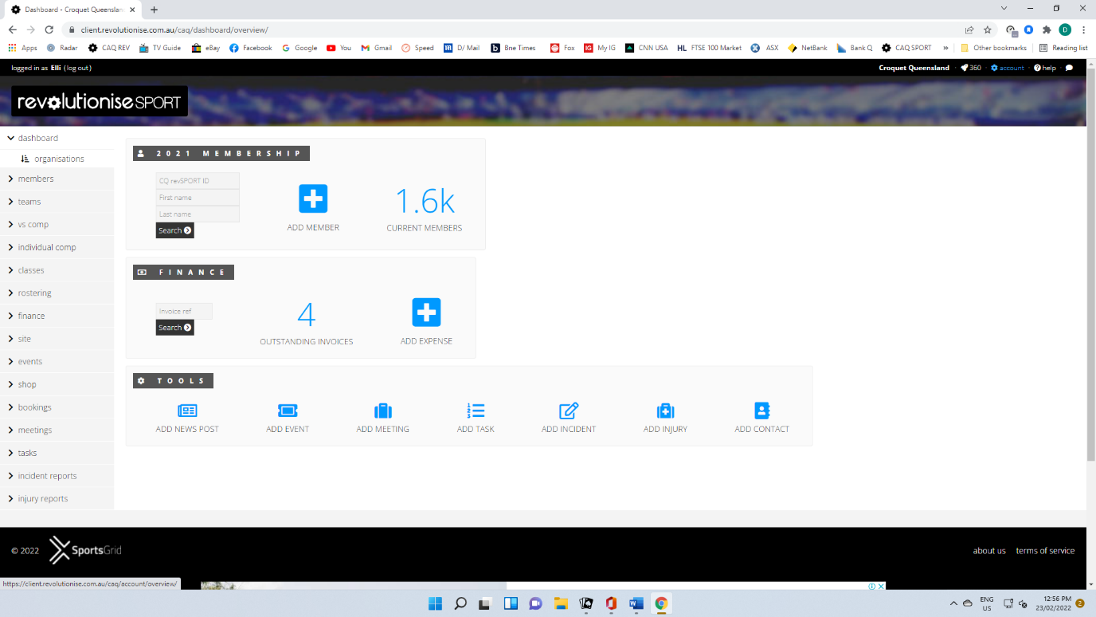
Select Members from the list on the left hand side of the page.

Step 2.
From the list in the top left of the screen select Members.
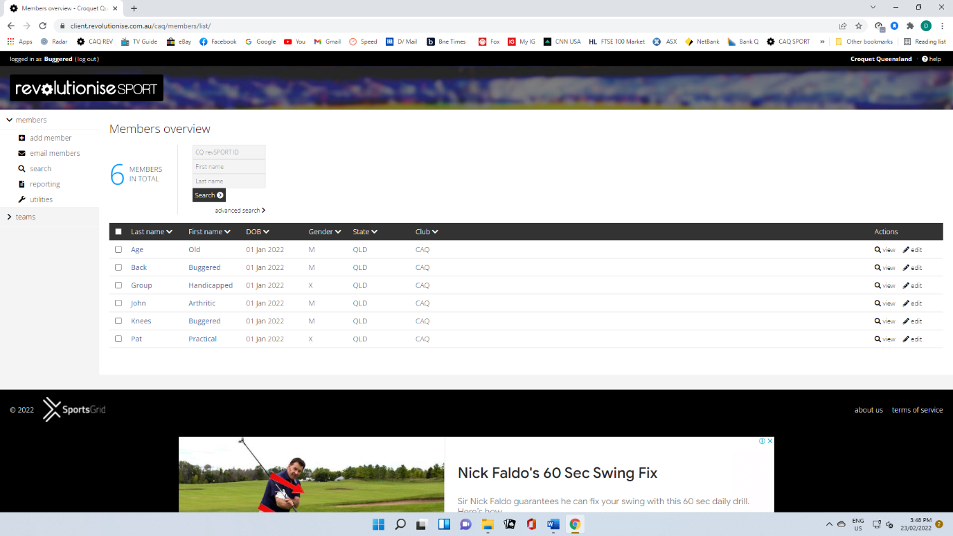
All of the clubs members are now visible, just scroll up or down the page as required. Having found the member who details you wish to change just select ‘edit’ from the far right of the screen.
That will take you into the same screen as you used to add a new member. Except this time the data is already there and you can simple change any detail necessary.
At the bottom of the screen is Save Details, just click on it and it’s job done.

Save Details

